**COMPARATIVE ANALYSIS OF VARIOUS MACHINE LEARNING, DEEP LEARNING AND HYBRID MODELS FOR AIR QUALITY PREDICTION**

*Report Submitted to the SASTRA Deemed to be University*

*as the Requirement of the course*

**CSE300 MINI PROJECT**

*Submitted by*

**Janupalli Saketh Reddy**

**(Reg No: 225003126)**

**Thumukunta Vamshi Karthikeya**

**(Reg No: 225003183)**

**M Krishna Kaushal**

**(Reg No: 225003199)**

**MAY 2024**





**Department of Computer Science and Engineering**

**SRINIVASA RAMANUJAN CENTRE**

**KUMBAKONAM, TAMIL NADU, INDIA – 612001**





**Department of Computer Science and Engineering**

**SRINIVASA RAMANUJAN CENTRE**

**KUMBAKONAM, TAMIL NADU, INDIA – 612001**

**Bonafide Certificate**

This is to certify that the report titled **"Comparative Analysis of various Machine Learning, Deep Learning And Hybrid Models For Air Quality Prediction"** submitted as a requirement for the course, **CSE300**: **MINI PROJECT** for B.Tech. is a bonafide record of the work done by **Mr. JANUPALLI SAKETH REDDY(Reg. No.225003126), Mr. THUMUKUNTA VAMSHI KARTHIKEYA (Reg. No.225003183), Mr. M KRISHNA KAUSHAL (Reg. No.225003199)** during the academic year 2023-24, in the Srinivasa Ramanujan Centre, under my supervision.

**Signature of Project Supervisor :**

**Name with Affiliation : Mrs. Vanitha M/AP-II/CSE/SRC/SASTRA**

**Date :**

Mini Project *Viva voce* held on _______________

**Examiner 1 Examiner 2**

**ACKNOWLEDGEMENTS**

We pay our sincere obeisance to the God Almighty for his grace and infinite mercy and for showing on us his choicest blessings.

We would like to express our thanks to our Chancellor **Prof.** **R. Sethuraman,** Vice Chancellor **Dr. S. Vaidhyasubramaniam** and Registrar **Dr. R. Chandramouli** for having given us an opportunity to be a student of this esteemed institution.

We express our deepest thanks to **Dr. V. Ramaswamy**, Dean and **Dr. A. Alli** **Rani**, Associate Dean, Srinivasa Ramanujan Centre for their constant support and suggestions when required without any reservations.

We express our gratitude to HOD in charge **Dr. V. Kalaichelvi**/ACP/CSE, Srinivasa Ramanujan Centre for her constant support and valuable suggestion for the completion of the project.

We exhibit our pleasure in expressing our thanks **Mrs. Vanitha M/AP-II/CSE**, our guide for her ever-encouraging spirit and meticulous guidance for the completion of the project.

We would like to place on record the benevolent approach and pain taking efforts of guidance and correction of **Dr. G Revathy APIII/CSE,** the project coordinator and all department staffs to whom we owe our hearty thanks for ever.

Without the support of our parents and friends this project would never have become reality.

We dedicate this work to our well-wishers, with love and affection.

**List of Figures**

|  |  |  |
| --- | --- | --- |
| **Figure No.** | **Title** | **Page No.** |
| 1 | Architecture Diagram | 3 |
| 2 | Formula | 6 |
| 3 | Comparison of MAE Values. | 24 |
| 4 | Comparison of MSE Values. | 25 |
| 5 | Comparison of RMSE Values. | 25 |
| 6 | Comparison of R-Squared Values. | 26 |
| 7 | Comparison of Evaluation Metrics. | 26 |

**List of Tables**

|  |  |  |
| --- | --- | --- |
| **Table No.** | **Table Name** | **Page No.** |
| 1 | Breakpoints | 5 |
| 2 | AQI Definition | 5 |
| 3 | Parameter Value Range | 6 |
| 4 | Evaluation Results | 24 |

**Abbreviations**

**AQI –** Air Quality Index

**DL –** Deep Learning

**GRU -** Gated Recurrent Unit

**IQR –** Inter Quartile Range

**KNN –** K Nearest Neighbor

**LR –** Linear Regression

**LSTM –** Long Short-Term Memory

**MAE –** Mean Absolute Error

**ML –** Machine Learning

**MSE -** Mean Square Error

**R2 –** R-SquaredScore

**RMSE –** Root Mean Square Error

**SVM –** Support Vector Machine

**Notations**

**ai =** Estimated Intercept

**AQI =** The (Air Quality) Index

**b =** Bias

**C =** Pollutant Concentration

**Clow =** Concentration breakpoint <=c

**Chigh =** Concentration breakpoint >=c

**ct ∈ Rh =** Vector to be used for cell state

**d =** Euclidean Distance

**f(x) =** Function with Least possible deviation

**ft ∈ Rh =** Activation vector used for Forget gate of LSTM unit

**ht ∈ Rh =** Output vector of LSTM unit. (Hidden State value)

**Ilow =** Index breakpoint respective to Clow

**Ihigh =** Index breakpoint respective to Chigh

**it ∈ Rh =** Activation vector used for Input gate of LSTM unit

**ot ∈ Rh =** Activation vector used for Output gate of LSTM unit

**T =** Training dataset

**w =** Vector of weights

**W ∈ R(h*d), U ∈ R(h*h), b ∈ R(h) =** Weight matrices and bias vector parameters that are trainable where superscripts ∈ h and ∈ d refer to the number of input features and number of hidden units respectively.

**X =** Real Value input Vector

**xi =** Input space

**xt ∈ Rd =** Vector to be used as input to LSTM unit

**Y =** Real Value output Vector

**φ(xi) =** High-Dimensional feature space

**σg** = Logarithmic Sigmoid function

**σc** = Hyperbolic tangent function

**σh =** Hyperbolic tangent function or identity function

**Abstract**

Concern over air pollution has grown to be a major issue affecting environmental sustainability and public health in today's fast urbanizing world. Accurate Air Quality Index (AQI) forecasting is becoming more and more important as cities grow and industrialization picks up speed, the goal of this project is to improve the sufficiency of current technologies in forecasting Air Quality Index (AQI) levels. Before relocating to any region that is filthy, the Air Quality Index (AQI) prediction can help them to take precautions regarding their health. Understanding how important AQI is for evaluating contaminants and directing regulatory actions, this project suggests a Hybrid Model for AQI prediction. The proposed model seeks to offer precise and up-to-date projections by utilising past air quality data, meteorological characteristics.

We can now analyze enormous volumes of data and discover intricate patterns and connections that conventional methods alone would not reveal, thanks to machine learning algorithms. Deep learning techniques further enhance predictive capabilities by automatically learning hierarchical representations of data. By combining these modern computational techniques, we can generate forecasts with unprecedented accuracy and gain valuable insights into the variables influencing air quality.

This project will aid in making educated decisions regarding environmental sustainability. In order to promote a cleaner and healthier future, the project is in line with the urge to enable communities and authorities to proactively battle air pollution.

**Keywords:** Air Quality Index, Air Pollution, Urbanization, Sustainability, Forecasting, Meteorological Characteristics.

**Table of Contents**

**Title Page No.**

Bonafide Certificate ii

Acknowledgements iii

List of Figures iv

List of Tables v

Abbreviations vi

Notations vii

Abstract viii

1. Summary of the base paper 1

2. Merits and Demerits of the base paper 7

3. Source Code 9

4. Snapshots 21

5. Conclusion and Future Plans 27

6. References 28

7. Appendix-Base Paper 30

**CHAPTER 1**

**SUMMARY OF THE BASE PAPER**

**Title:** Air Quality Index prediction using an effective hybrid deep learning model

**Journal:** Environmental Pollution

**Publisher:** ELSEVIER

**Year:** 2022

**Indexing:** SCI-E

* 1. **Summary:**
* The paper emphasizes the critical importance of forecasting the Air Quality Index (AQI) to empower individuals in protecting their health, particularly in regions plagued by heightened pollution levels.
* It systematically examines a range of computational models, spanning both machine learning and deep learning methodologies, to evaluate their efficacy in AQI prediction.
* Following rigorous analysis, the study discerns that the proposed hybrid Long Short-Term Memory (LSTM) and Gated Recurrent Unit (GRU) model outperforms its standalone counterparts.
* This hybrid model demonstrates commendable performance metrics, including a Mean Absolute Error (MAE) of 36.11 and an impressive R-squared (R^2) coefficient of 0.84.
* Notably, the hybrid model's capability in AQI prediction is underscored by its significantly reduced error rates.
* These findings underscore the potential of advanced computational techniques to enhance the accuracy and reliability of AQI forecasts.
* Consequently, proactive interventions can be facilitated to mitigate the health risks posed by ambient air pollution, based on more precise AQI predictions.

**1.2 Research Addressed:**

* The research addresses the urgent necessity for precise Air Quality Index (AQI) forecasts in densely polluted urban areas, highlighting its profound implications for managing public health.
* By developing and evaluating a hybrid deep learning model (LSTM-GRU), the study seeks to refine existing predictive methods, comparing the hybrid model's performance with other commonly used machine learning and deep learning models for AQI prediction.
* Emphasis is placed on key metrics like Mean Absolute Error (MAE) and R-squared (R2) values, underscoring the significance of accuracy in AQI predictions to inform individuals about potential health hazards linked to air pollution.
* Additionally, the research underscores the vital role of predictive models in facilitating proactive measures to mitigate the adverse health consequences of poor air quality.
* Through demonstrating the hybrid model's superior accuracy and performance metrics, the study not only advances the realm of air quality prediction but also furnishes practical insights for policymakers, environmental agencies, and healthcare professionals to effectively manage and alleviate the impacts of air pollution on public health.

**1.3 Proposed Solution:**

* The proposed solution integrates LSTM (Long Short-Term Memory), GRU (Gated Recurrent Unit), and RNN (Recurrent Neural Network) architectures.
* LSTM networks excel in retaining information over extended sequences, crucial for capturing long-term patterns in AQI (Air Quality Index) data.
* GRU networks offer computational efficiency compared to LSTM, while still effectively capturing short-term dependencies.
* RNNs provide a flexible framework for processing sequential data.
* By combining LSTM, GRU and RNN, the hybrid model leverages their complementary strengths, enhancing both short-term fluctuations and long-term patterns in AQI data.
* The hybrid model undergoes training using historical AQI data, optimizing its parameters to minimize prediction errors through iterative adjustments.
* During evaluation, the hybrid model demonstrates superior performance compared to standalone LSTM, GRU and RNN models, as well as traditional ML methods such as linear regression, support vector machines (SVM), and k-nearest neighbors (KNN).
* The integration of LSTM, GRU, and RNN allows the model to capture both short-term fluctuations and long-term trends in AQI data more effectively, leading to improved prediction accuracy.

**1.4 Proposed Architecture:**

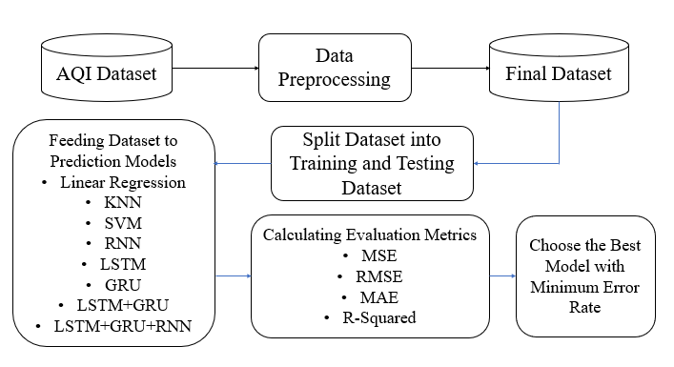

Fig. 1. Architecture Diagram

**1.5 Prediction Models Used:**

**1.5.1 Linear Regression (LR):**

* Utilized for its simplicity and interpretability in modeling linear relationships between input features and AQI values.
* Predicts AQI levels based on a weighted sum of input variables, assuming a linear relationship between predictors and AQI.

Formula: 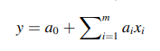

**1.5.2 Support Vector Machines (SVM):**

* Employed to find the optimal hyperplane that separates different AQI classes.
* Classifies AQI levels based on their proximity to the decision boundary defined by the hyperplane.

Formula: 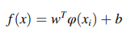

**1.5.3 K-Nearest Neighbors (KNN):**

* Predicts the AQI of a given location based on the majority class of its k nearest neighbors.
* Utilizes the proximity of data points in the feature space to determine AQI levels.

Formula: 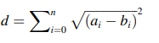

**1.5.4 Recurrent Neural Network (RNN):**

* A class of neural networks specifically designed to process sequential data by retaining information in memory over time.
* Suitable for tasks such as time series forecasting, where capturing temporal dependencies is crucial.

Formula:

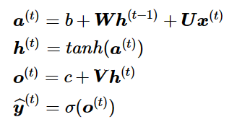

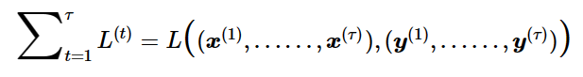

**1.5.5 Long Short-Term Memory (LSTM) Network:**

* A type of recurrent neural network (RNN) known for its ability to capture long-term dependencies in sequential data.
* Effective in learning and remembering patterns over extended periods, making it suitable for modeling the complex dynamics of air quality changes.

Formula:

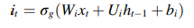

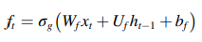

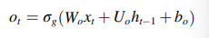

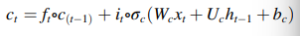

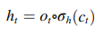

**1.5.6 Gated Recurrent Unit (GRU) Network:**

* Another type of recurrent neural network designed to address the vanishing gradient problem and improve training efficiency.
* Simplifies the architecture by merging the memory and input gates, leading to faster training and inference times compared to LSTM.

Formula:

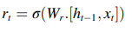

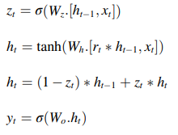

**1.5.7 Hybrid LSTM-GRU Model:**

* Integrates the strengths of both LSTM and GRU architectures for enhanced AQI forecasting.
* Combines LSTM's proficiency in capturing long-term dependencies with GRU's computational efficiency and effective management of short-term information.
* Offers a robust solution capable of discerning both short-term fluctuations and long-term patterns in AQI data.
* Outperforms standalone models and traditional machine learning algorithms, providing accurate forecasts for air quality management and public health initiatives in Delhi.

**1.5.8 LSTM+GRU+RNN Model:**

* Comprehensive hybrid model combining LSTM, GRU, and Recurrent Neural Network (RNN) architectures.
* Incorporates LSTM's long-term memory retention, GRU's computational efficiency, and RNN's flexibility.
* Excels in capturing complex temporal dependencies, making it well-suited for tasks such as air quality forecasting where both short-term and long-term patterns are critical.
* Offers a robust solution capable of discerning both short-term fluctuations and long-term patterns in AQI data.
* Outperforms standalone models and traditional machine learning algorithms, providing accurate forecasts for air quality management and public health initiatives in Delhi.

**1.5.9 Definition:**

|  |  |  |  |  |  |  |  |  |
| --- | --- | --- | --- | --- | --- | --- | --- | --- |
| **AQI Category** | **PM10** | **PM2.5** | **NO2** | **O3** | **CO** | **SO2** | **NH3** | **Pb** |
| Good (0-50) | 0-50 | 0-30 | 0-40 | 0-50 | 0-1.0 | 0-40 | 0-200 | 0-0.5 |
| Satisfactory (51-100) | 51-100 | 31-60 | 41-80 | 51-100 | 1.1-2.0 | 41-80 | 201-400 | 0.5-1.0 |
| Moderate (101-200) | 101-250 | 61-90 | 81-180 | 101-168 | 2.1-10 | 18-380 | 401-800 | 1.1-2.0 |
| Poor (201-300) | 251-300 | 91-120 | 181-280 | 169-280 | 10-17 | 381-800 | 801-1200 | 2.1-3.0 |
| Very Poor (301-400) | 351-430 | 120-250 | 281-400 | 209-748 | 17-34 | 801-1600 | 1200-1800 | 3.1-3.5 |
| Severe (401-500) | 430+ | 250+ | 400+ | 748+ | 34+ | 1600+ | 1800+ | 3.5+ |

Table 1: Breakpoints

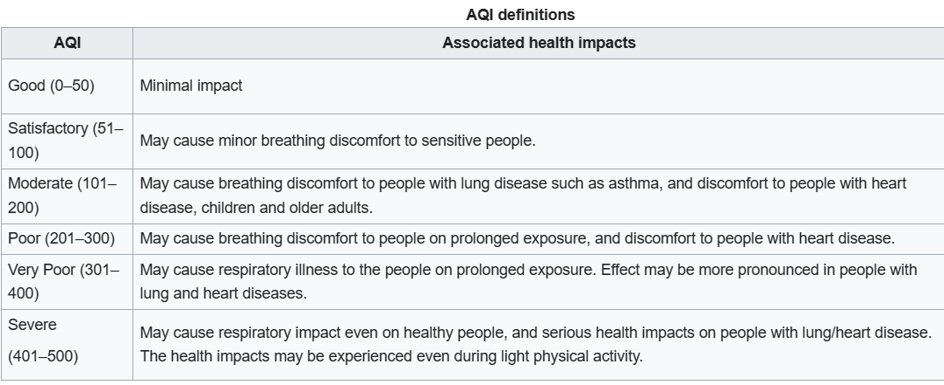

Table 2: AQI Definition

**1.5.10 Formula:**

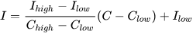

Fig 2: Formula

|  |  |  |  |  |  |  |  |
| --- | --- | --- | --- | --- | --- | --- | --- |
| **AQI Category** | **PM10** | **PM2.5** | **NO2** | **O3** | **CO** | **SO2** | **Pb** |
| 0-50 | 0-54 | 0-9 | 0-53 | 0-50 | 0-4.4 | 0-35 | 0-0.5 |
| 51-100 | 55-154 | 9.1-35.4 | 54-100 | 51-125 | 4.5-9.4 | 36-75 | 0.5-1.0 |
| 101-200 | 155-254 | 35.5-55.4 | 101-360 | 125-164 | 9.5-12.4 | 76-185 | 1.1-2.0 |
| 201-300 | 255-354 | 55.5-125.4 | 361-649 | 165-204 | 12.5-15.4 | 186-304 | 2.1-3.0 |
| 301-400 | 355-424 | 125.5-225.4 | 650-1249 | 205-404 | 15.5-30.4 | 305-604 | 3.1-3.5 |
| 401-500 | 425-604 | 225.5-325.4 | 1250-2049 | 405-604 | 30.5-50.4 | 605-1004 | 3.5-4.4 |

Table 3: Parameter Value Range

**CHAPTER 2**

**MERITS AND DEMERITS OF THE BASE PAPER**

**2.1 MERITS**

* This base paper includes the development of a hybrid LSTM-GRU model for accurate prediction of the Air Quality Index (AQI).
* Both LSTM and GRU architectures are designed to address the vanishing gradient problem encountered in traditional RNNs, allowing them to capture long-term dependencies in sequential data.
* Memory cell processes in LSTM and GRU designs let them to selectively remember or forget information over time. This feature helps in AQI prediction by enabling the model to retain significant historical observations while removing unimportant noise.
* Compared to linear models like Linear Regression and SVM, LSTM and GRU networks are better able to capture these intricate interactions because of their capacity to simulate nonlinearities through recurrent connections and memory cells. Although KNN can capture nonlinear relationships.
* The hybrid LSTM-GRU model outperforms standalone ML and DL models in terms of Mean Absolute Error (MAE) and R-squared (R2) values.
* This hybrid model shows superior performance with a low MAE value of 36.11, indicating its accuracy in predicting the Air Quality Index.
* The R2 value of the hybrid model is 0.84, demonstrating a strong correlation between the predicted and actual AQI values.
* The hybrid model mentioned in base paper shows supremacy in performance compared to LSTM, Linear Regression, GRU, K-Nearest Neighbor, and Support Vector Machine models.
* This model considers pollutant content and meteorological characteristics, highlighting the significance of AQI prediction.
* The proposed model provides a more accurate prediction of AQI values, essential for public health and environmental sustainability.

**2.2 DEMERITS**

* The study is restricted to a single city, and other data sources would be needed to extend the prediction of AQI to other locations.
* This paper ignores the accuracy of machine learning and deep learning model while mainly focusing on proposed model. As the input data is limited, the accuracy of the model will not be high.
* Any conflicting financial interests or personal connections that might have impacted the work are not included in the report.
* LSTM and GRU architectures are more complex models.
* The study does not provide a detailed discussion of potential biases or limitations in the methodology used for AQI prediction.

**CHAPTER 3**

**SOURCE CODE**

**3.1 Preprocessing**

**3.1.1 Step-1**

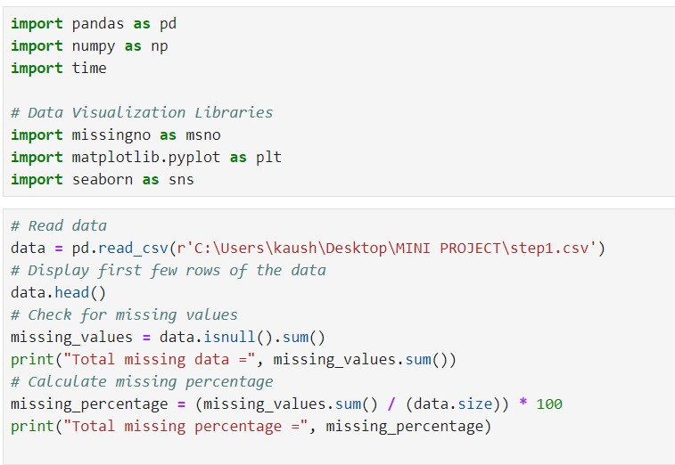 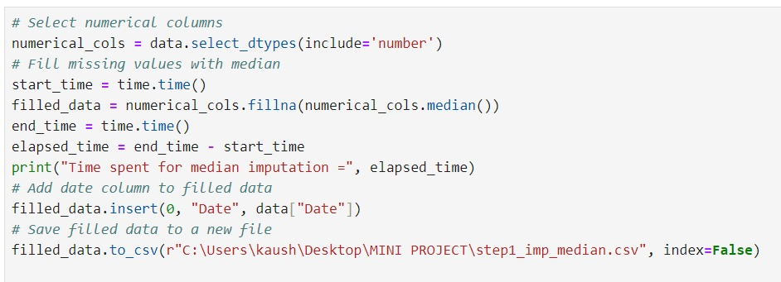

**3.1.2 Step-2**

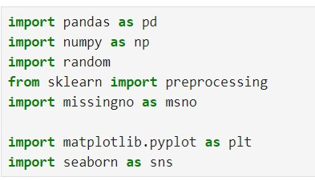

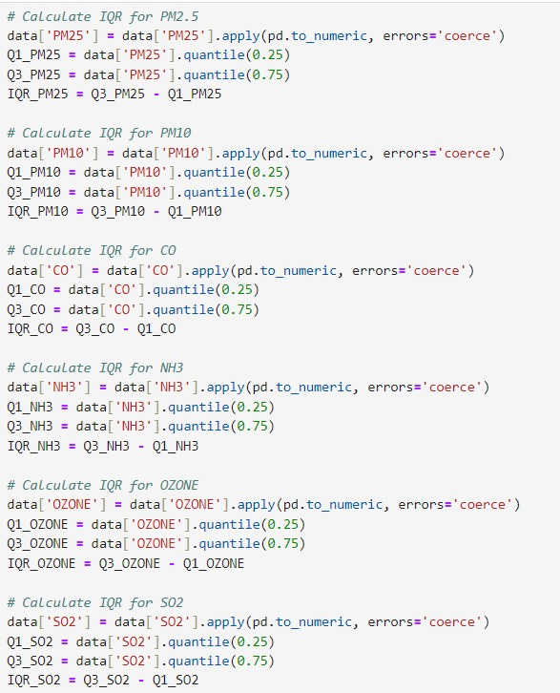

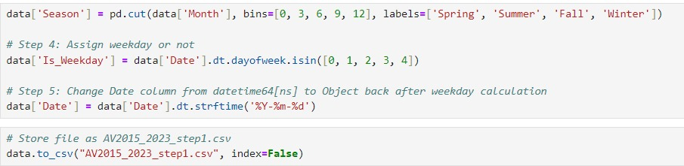

**3.1.3 Step-3**

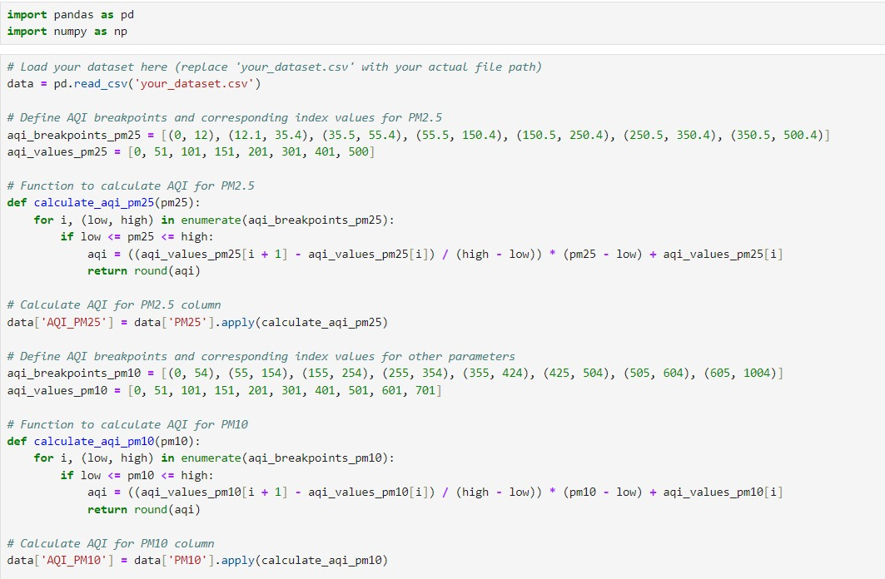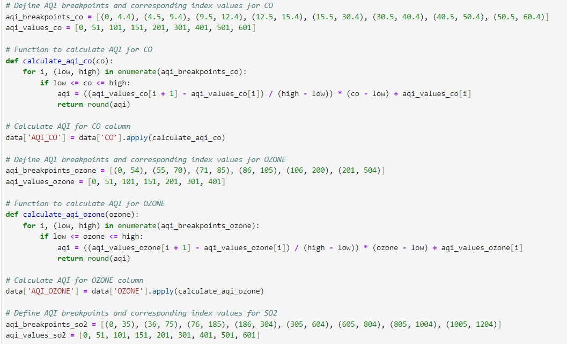

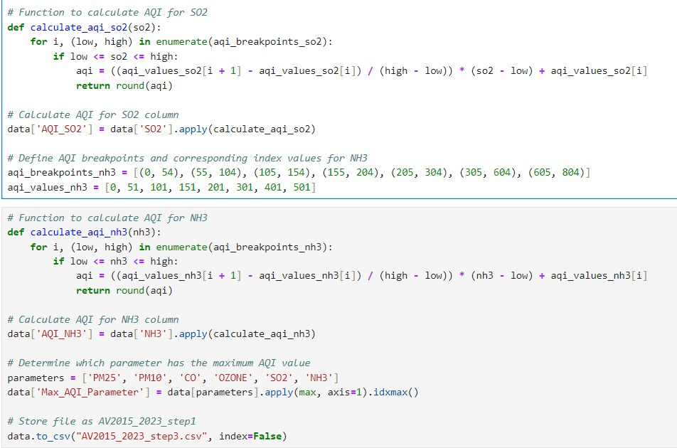

**3.2 Machine Learning Models**

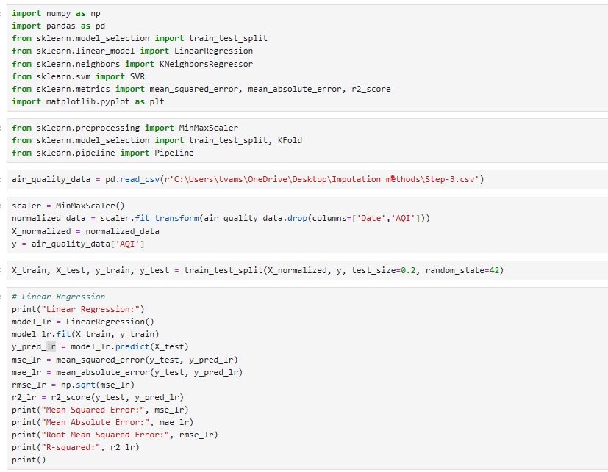

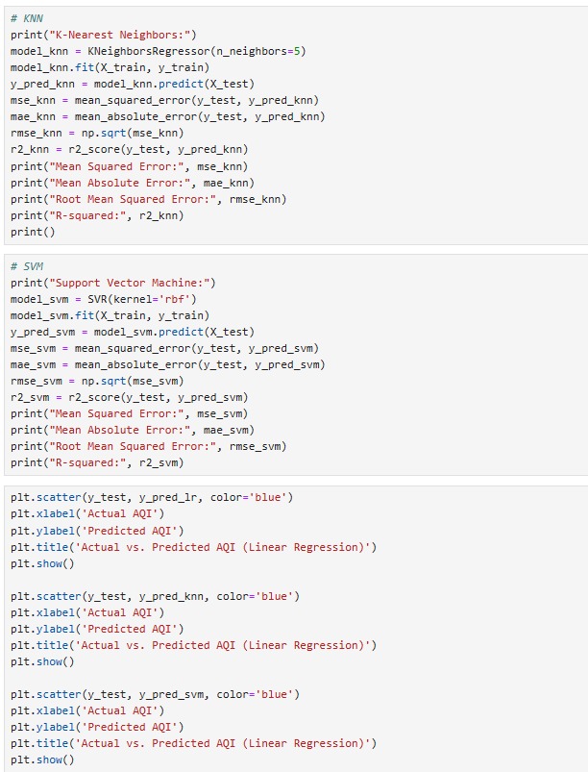

**3.3 Deep Learning Models**

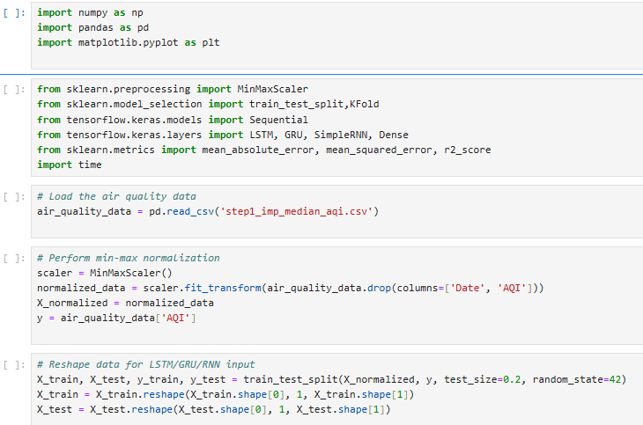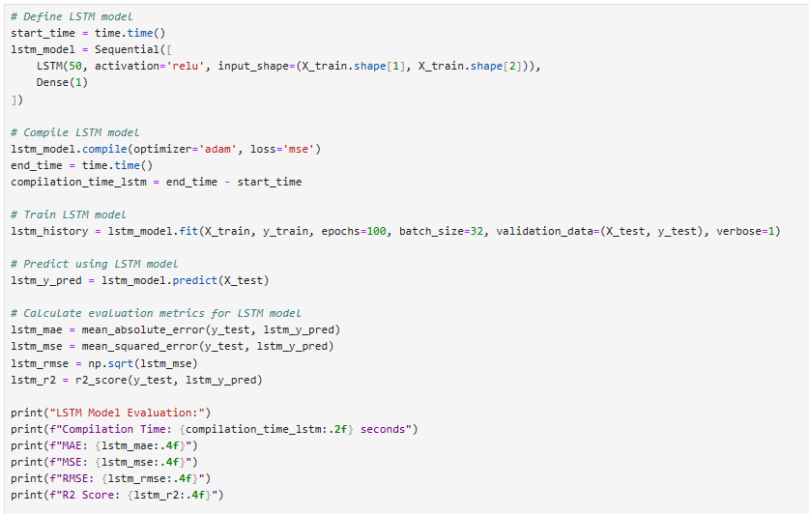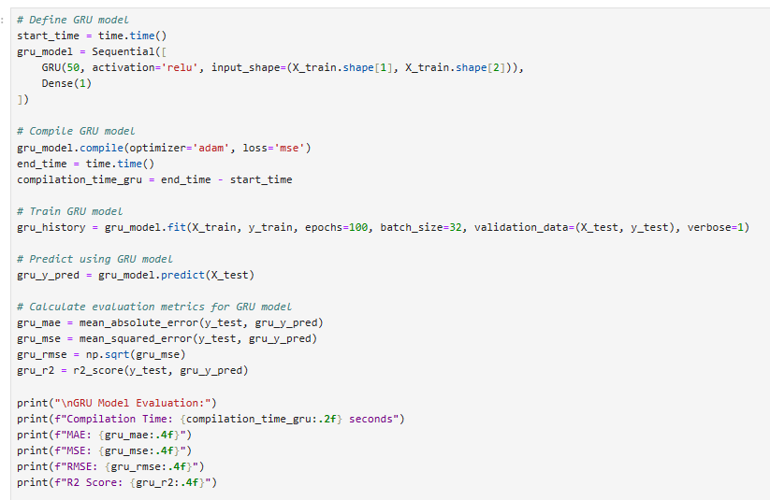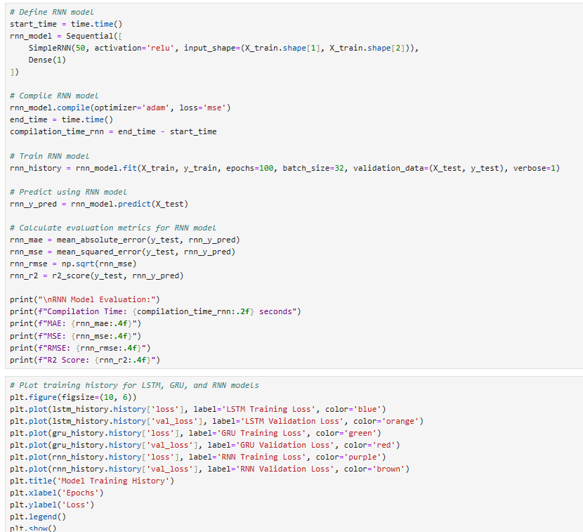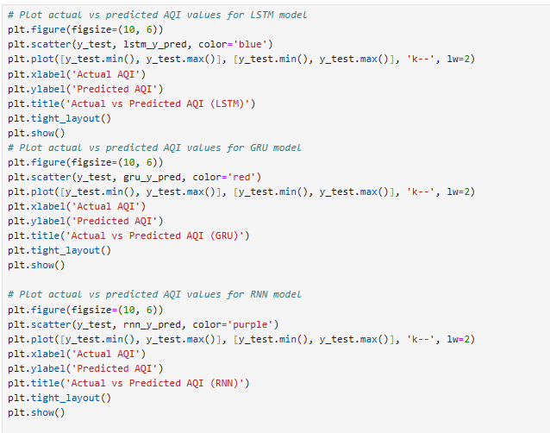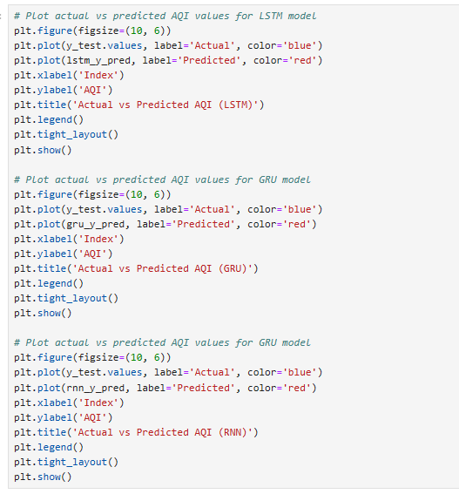

**3.4 Hybrid Models**

**3.4.1 LSTM + GRU**

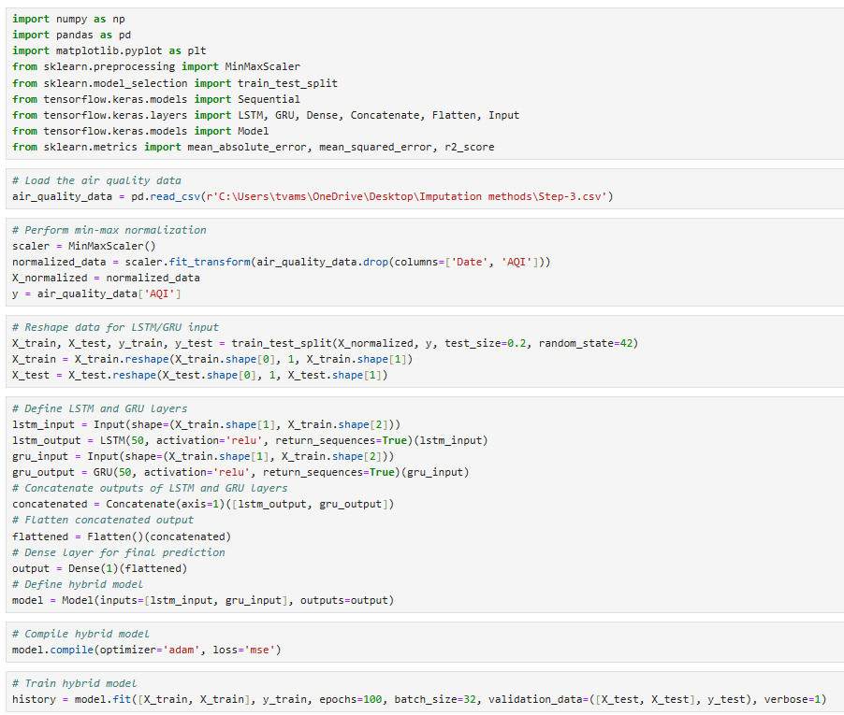

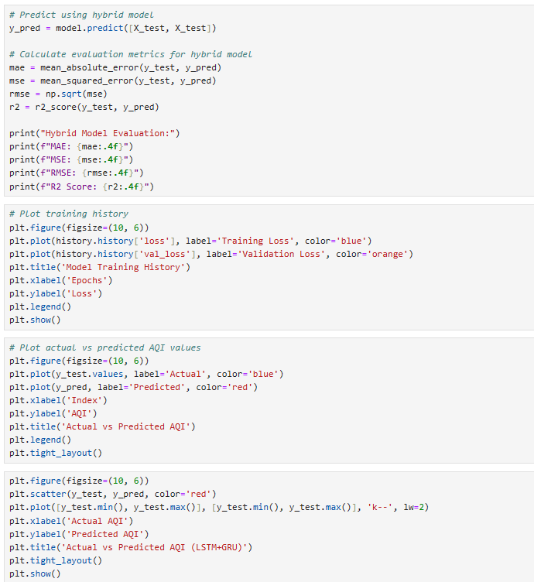

**3.4.2 LSTM + GRU +RNN**

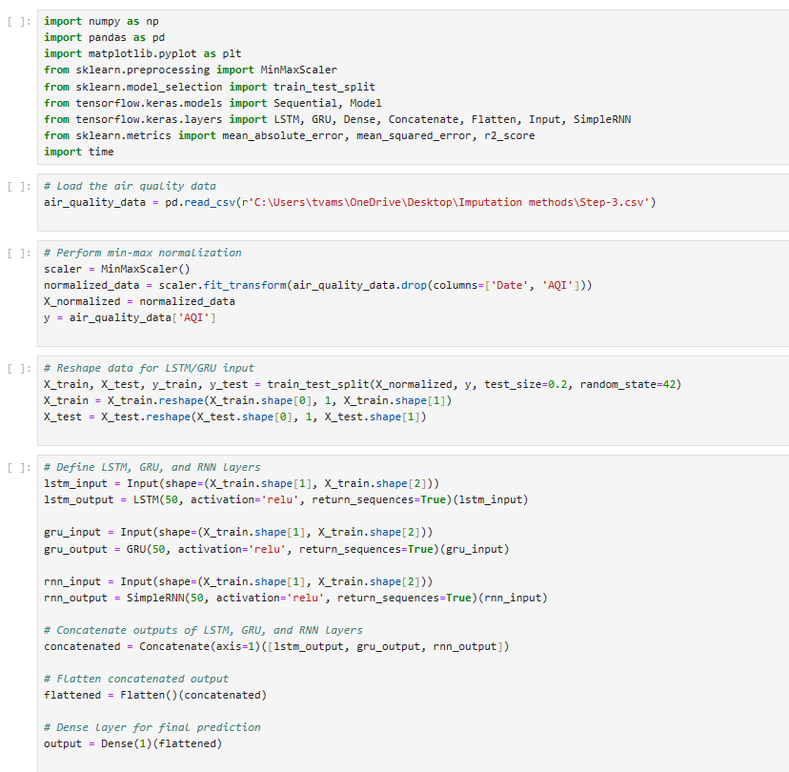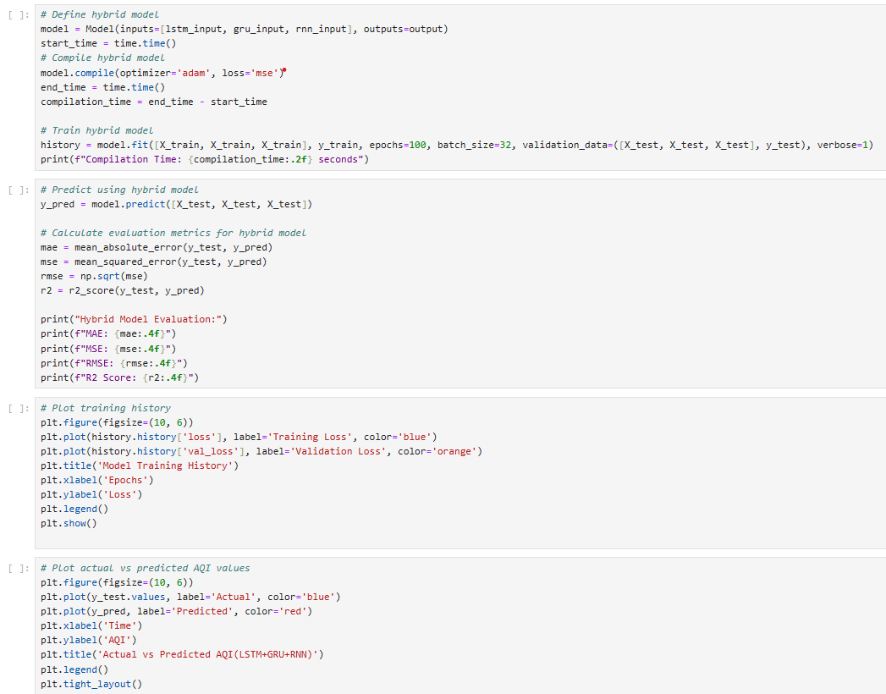

**CHAPTER 4**

**SNAPSHOTS**

**4.1 Linear Regression:**

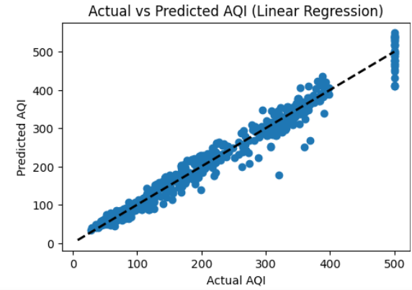 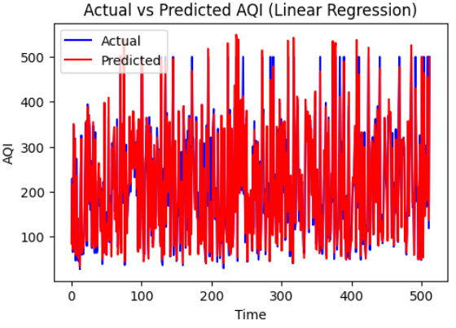

**4.2 Support Vector Machine:**

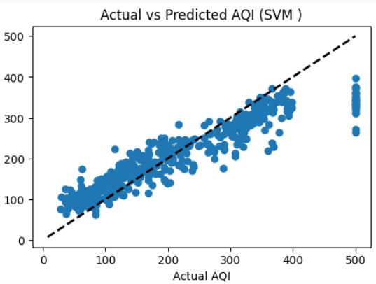 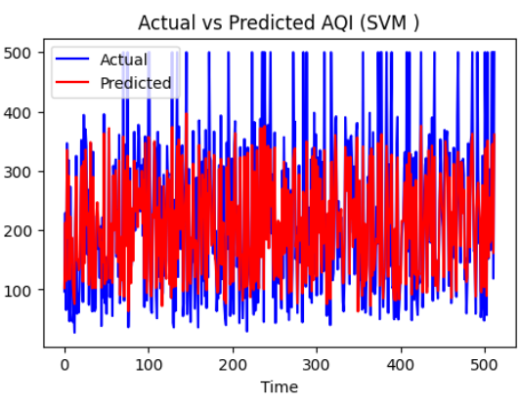

**4.3 K-Nearest Neighbor:**

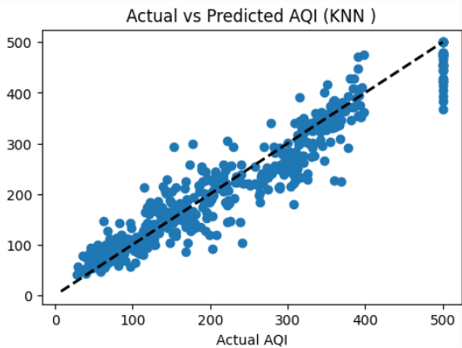 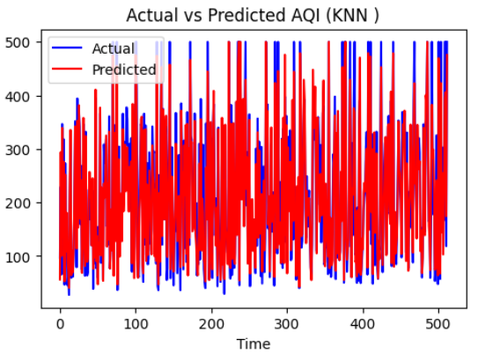

**4.4 Recurrent Neural Network:**

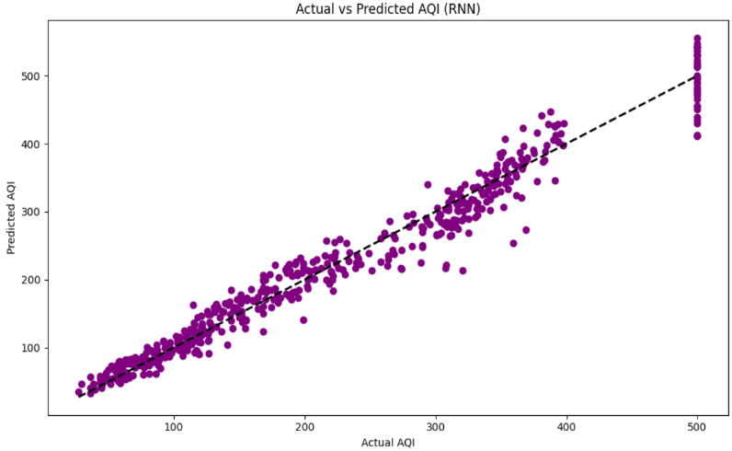 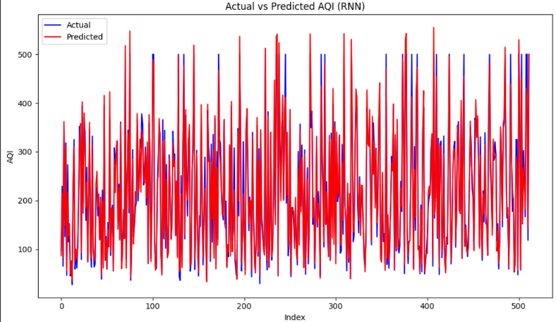

**4.5 Long Short-Term Memory:**

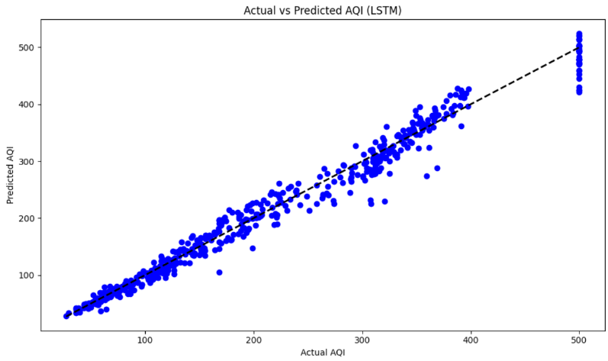 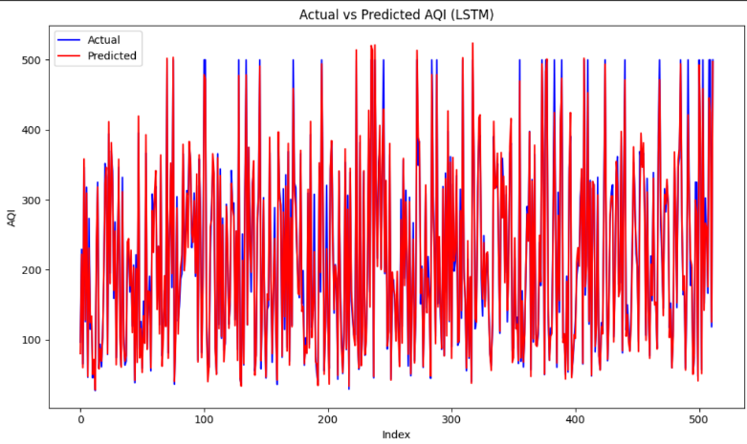

**4.6 Gated Recurrent Units:**

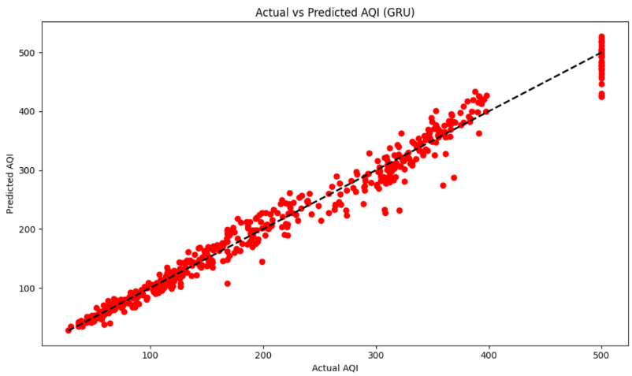 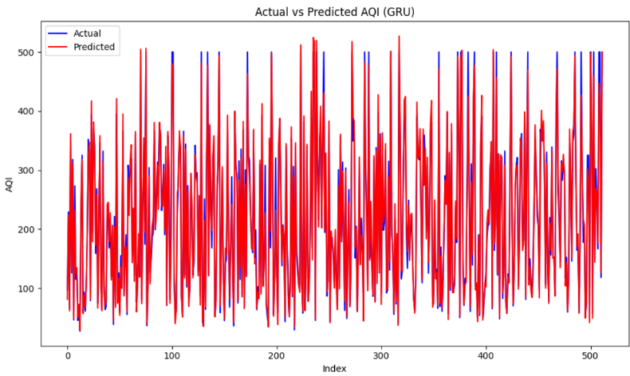

**4.7 LSTM + GRU**

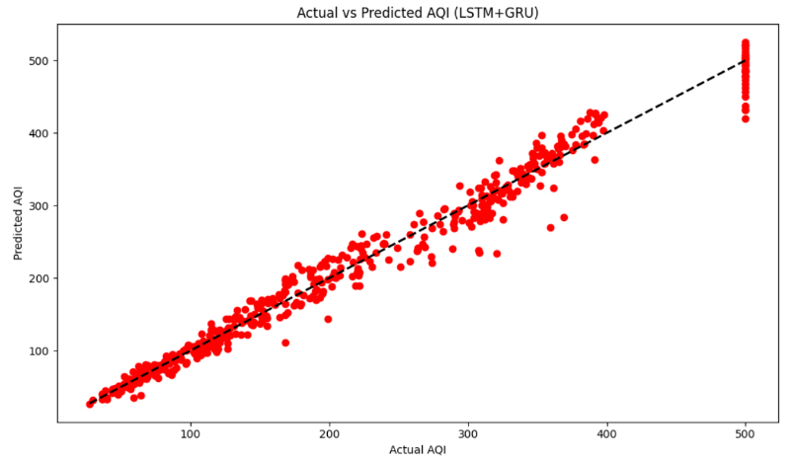 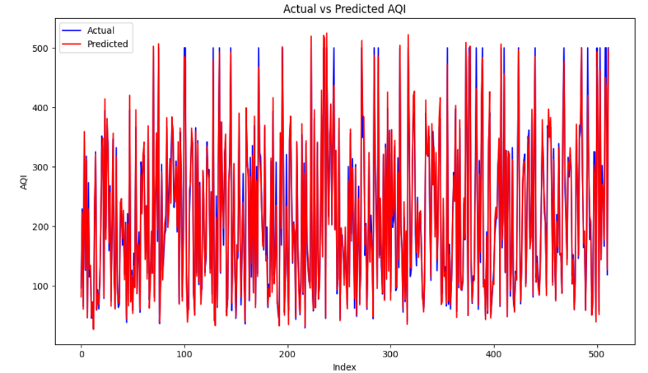

**4.7 LSTM + GRU + RNN**

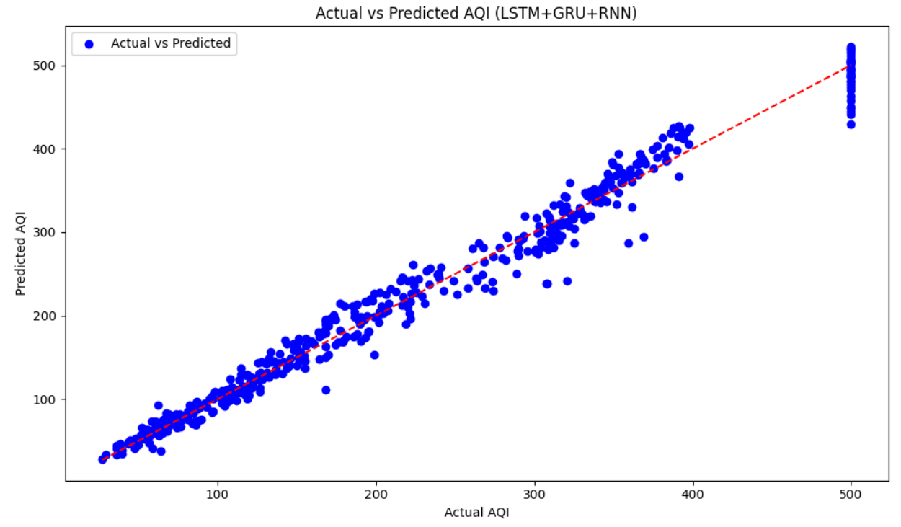 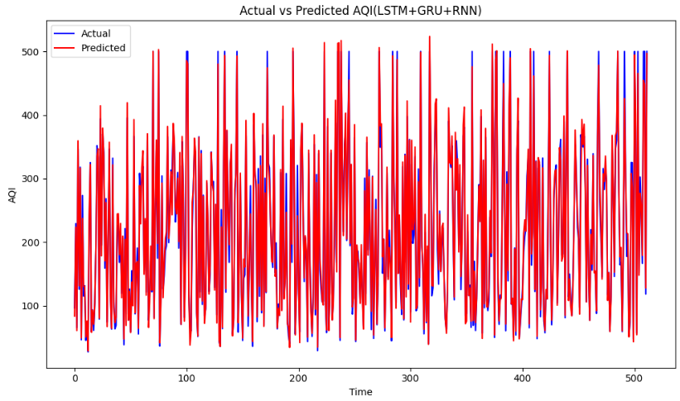

**4.8 Evaluation Results** 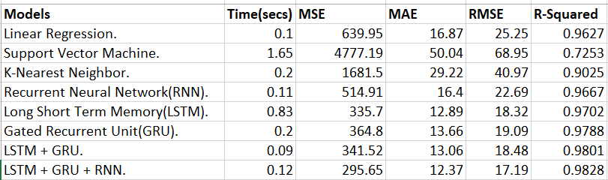

Table 4. Evaluation Results

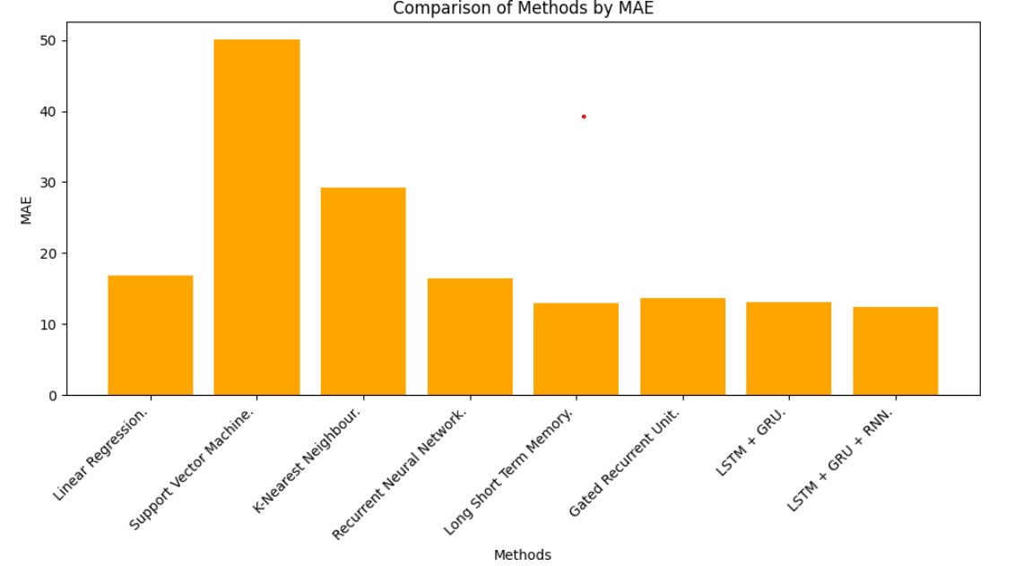

Fig 3: Comparison of MAE Values.

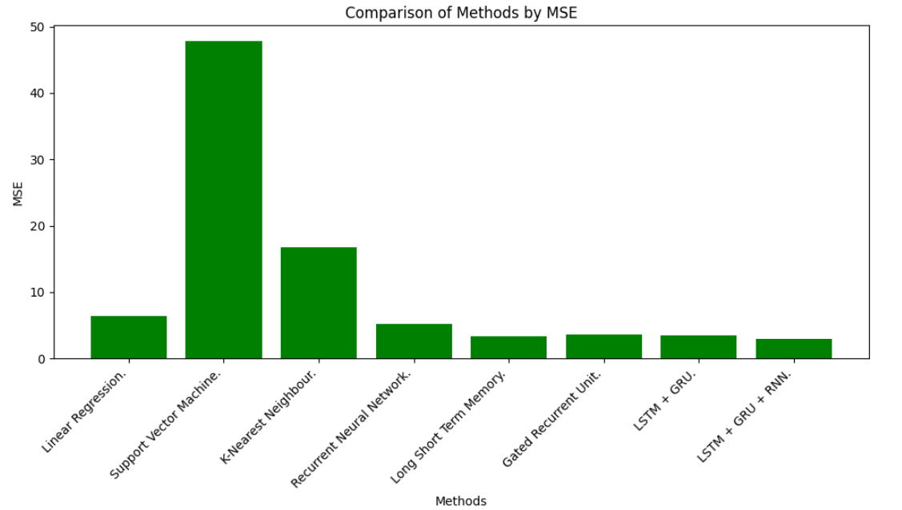

Fig 4: Comparison of MSE Values.

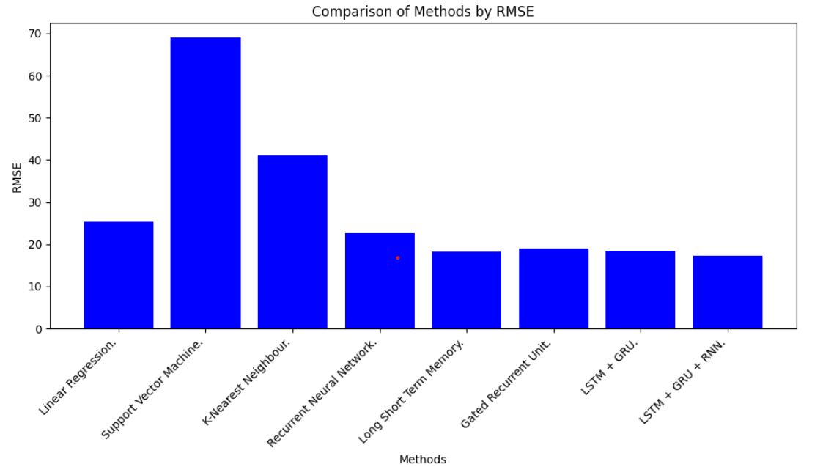

Fig 5: Comparison of RMSE Values.

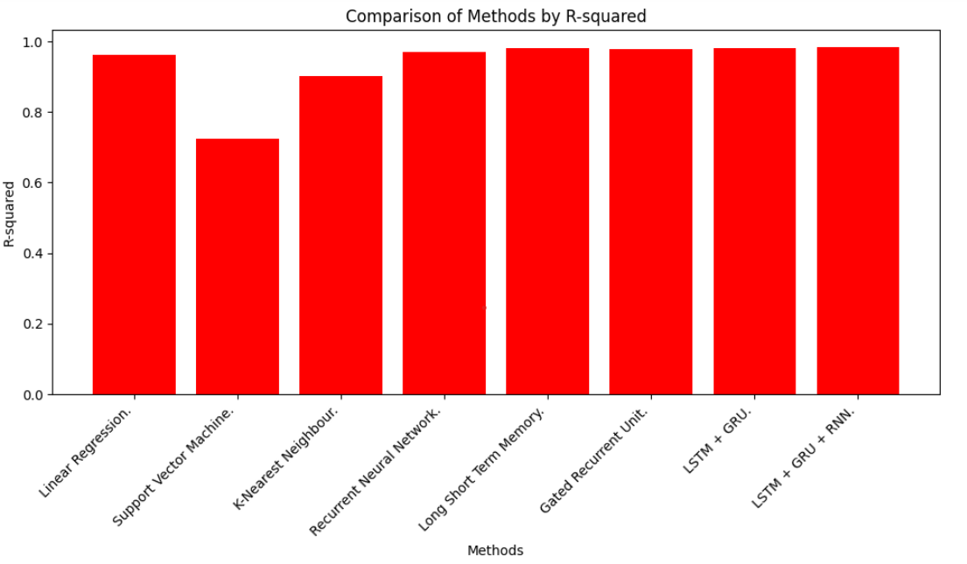

Fig 6: Comparison of R-Squared Values.

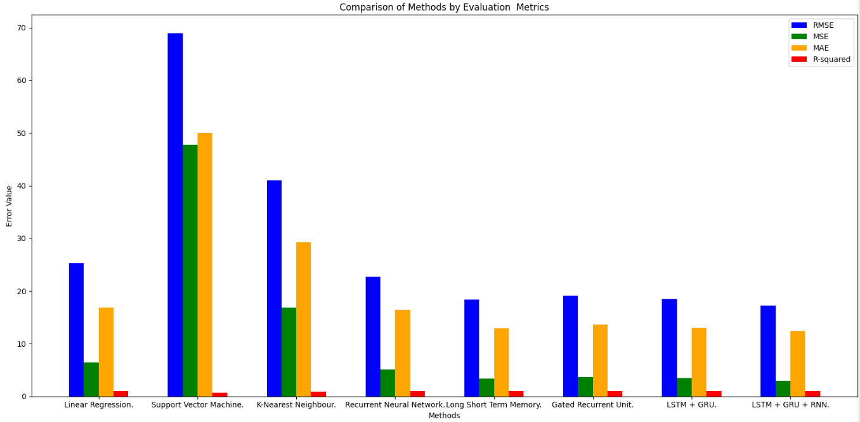

Fig 7: Comparison of Evaluation Metrics.

**CHAPTER 5**

**CONCLUSION AND FUTURE PLANS**

The conclusion of our project underscores the critical importance of anticipating the Air Quality Index (AQI) to safeguard public health. Despite the growing significance of this issue, the research landscape in the field remains inadequate. However, the study achieves a significant breakthrough by introducing a hybrid LSTM-GRU model, as well as an additional LSTM-GRU-RNN model, developed by our team, both of which exhibit impressive performance metrics.

Moving forward, our intentions involve actively developing the proposed approach beyond its current limitations. This expansion includes implementing the hybrid LSTM-GRU-RNN model, alongside the LSTM-GRU model, to predict AQI in a wide range of urban contexts beyond the initial study location. Furthermore, there is a strong emphasis on enhancing the reliability of future projections by advocating for the use of solid and reputable data sources.

Looking forward, the envisioned trajectory entails a proactive and expansive approach towards leveraging the hybrid model's capabilities. This includes extending its application to predict AQI in diverse urban landscapes, transcending the confines of the original study area. By encompassing varied geographical and environmental factors, the aim is to develop a versatile and adaptable framework capable of addressing the multifaceted challenges posed by AQI prediction.

Furthermore, paramount importance is attributed to the enhancement of data reliability and robustness in future predictions. This necessitates advocating for the utilization of high-quality, comprehensive datasets sourced from reputable sources. By anchoring predictions on reliable data foundations, the aim is to mitigate uncertainties and improve the overall accuracy and confidence in AQI forecasts.

In essence, the outlined future plans encapsulate a holistic approach towards advancing AQI prediction methodologies. By combining innovation, rigorous evaluation, and a commitment to data integrity, the research endeavours to not only bridge existing knowledge gaps but also pave the way for more informed and effective strategies in safeguarding public health against the detrimental effects of air pollution.

**CHAPTER 6**

**REFERENCES**

[1] Juxin Cao,Uzair Aslam Bhatti, Siling Feng, Mengxing Huang, Ahmad Hasnaing,”Air Quality Index Predictions with a Hybrid Forecasting Model: Combining Series Decomposition and Deep Learning Techniques” in IEEE 6th International Conference on Pattern Recognition and Artificial Intelligence (PRAI) , 2023 {keywords: AQI prediction, Air Quality Index, Hybrid Forecasting Model, LSTM, Deep Learning, Machine learning, Support Vector Machine}

[2] Yuan Zhongjie, Wang Shengwei, Wang Ze, “Air quality prediction method based on the CS-LSTM” in International Conference on Data Science and Information Technology, 2022 {Keywords: Component, air quality prediction, AQI, Prediction Accuracy, Optimal Parameters, LSTM model, CS-LSTM model}

[3] Guohui Li, Yuze Tang, Hong Yang, “A new hybrid prediction model of air quality index based on secondary decomposition and improved kernel extreme learning machine” in Chemosphere, 2022, {Keywords: Air quality index prediction, Multivariate multiscale dispersion entropy, Complete ensemble empirical mode decomposition with adaptive noise, Variational mode decomposition, Kernel extreme learning machine }

[4] Chenchen Li, Yu Bin Bao, “Research on Air Quality Prediction Based on Machine Learning” in 2nd International Conference on Intelligent Computing and Human-Computer Interaction (ICHCI), 2021, {Keywords: Machine learning, Random Forest, Air Quality Data, Air Quality Prediction, Air quality prediction, Regression algorithm}

[5] R Janarthanan, P Partheeban, K Somasundaram, P Navin Elamparithi, “A deep learning approach for prediction of air quality index in a metropolitan city” in Sustainable Cities and Society, 2021, {Keywords: Air quality index, Deep learning, LSTM model, National Air Monitoring Program}

[6] Ruijun Yang, Xueqi Hu, Lijun He, Shang Hai, “Prediction of Shanghai air quality index based on BP neural network optimized by genetic algorithm” in International Symposium on Computational Intelligence and Design, 2020, {Keywords: bp neural network, AQI (air quality index), Mean Square Error, Air QualityIndex}

[7] Wang Zhenghua, Tian Zhihui, “Prediction of air quality index based on improved neural network.” in International Conference on Computer Systems, Electronics and Control (ICCSEC), 2017, {Keywords: Xuchang city, air quality index prediction, Genetic algorithm, neural network}

[8] Chuanting Zhang, Dongfeng Yuan, “Fast Fine-Grained Air Quality Index Level Prediction Using Random Forest Algorithm on Cluster Computing of Spark.” in IEEE 12th Intl Conf on Ubiquitous Intelligence and Computing, 2015, {Keywords: Big data, air quality prediction, Spark, random forest}

[9] Dataset for Air Quality data: [National Air Quality Index (cpcb.gov.in)](https://airquality.cpcb.gov.in/AQI_India/)

[10] Dataset for meteorological data: [POWER | Data Access Viewer (nasa.gov)](https://power.larc.nasa.gov/data-access-viewer/)

[11] Information about AQI: [Air Quality Index - Wikipedia](https://en.wikipedia.org/wiki/Air_quality_index)

**CHAPTER 7**

**APPENDIX – BASE PAPER**